# IOT Based Smart home automation

A building automation for a home, called a smart home  or  smart house.

Our home automation system will monitor and control home appliances such as up to 3 AC lighting, a AC Fan and monitor surrounding Temperature and Humidity .

It may also include [home security](https://en.wikipedia.org/wiki/Home_security) such as access control and alarm systems.

A home automation system typically connects controlled devices to a central [smart home hub](https://en.wikipedia.org/wiki/Smart_home_hub) (sometimes called a "[gateway](https://en.wikipedia.org/wiki/Residential_gateway)"). Here we have used ESP Rainmaker platform.

The [user interface](https://en.wikipedia.org/wiki/User_interface) for control of the system uses a mobile phone application, or a Personal Assistant like ALEXA / GOOGLE that may also be accessible from anywhere in the world.

While there are many competing Smart home devices, we increased our efforts to make this something special.

That is,

* It can control up to 3 AC devices & a AC Fan whose speed from 0-4.
* This project consists of temperature & humidity sensor for monitoring. So everything is combined in one.
* For demo I used table Fan instead of AC fan. Therefore, we can also control its Table light.
* It can be controlled by ESP Rainmaker Mobile App & also Alexa & Google Assistant.
* It is not just made for demonstration but it is mainly made for real life application use, as you can see we are controlling AC appliances. So it is ready to go project.
* Special feature of this project is that it remembers its devices state when main supply failure occurs, so that when power is back it automatically restore its devices state.
* A schedule (timer) feature, you can easily set timer in your mobile app

In order to turn ON device at specific Day/ Time.

* And we can easily add family members to this device by just adding there

Email ID or scanning the QR Code.

* If You want other customizable features like to turn ON fan at 30*c automatically, then it can be easily set in the mobile app.
* This completely is Handmade Project from PCB to entire connections.
* The components we used in this project is 75% from E Waste (Electronic Waste).

Home automation has high potential for sharing data between family members or trusted individuals for personal security and could lead to energy saving measures with a positive environmental impact in the future.

# Components

|  |  |
| --- | --- |
| NAME | Qnt |
| ESP 32 Board | 1 |
| 5v Relay | 6 |
| DHT 11 **Temperature sensor** | 1 |
| **1k ohm**  **resister** | 6 |
| **Diodes**  **14007** | 6 |
| **Transistors**  **BC547** | 6 |
| Power supply5v | 1 |
| AC Fanregulator | 1 |
| Connectors **etc** | - |

# program the ESP32 using Arduino IDE.

**Update the Preferences –>** Additional boards Manager URLs: <https://raw.githubusercontent.com/espressif/arduino-esp32/gh-pages/package_esp32_index.json>

* Then install the **ESP32** board (Version: **2.0.3**) from the Board manager
* Download the required libraries

**SimpleTimer-master & DHT Library**

* After uploading the code to ESP32,
* Open the serial monitor, and select **Baud Rate: 115200.**
* hen **press and hold the BOOT button** of ESP32 for at least **4 seconds.**
* After releasing the BOOT button, a QR code will appear on the Serial Monitor.
* Now, **copy the URL**, just below the QR code, and **open the URL in a browser.**
* This QR code is unique, so you can print the QR code. Later on, if you want to change the Wi-Fi details, you can use the same QR code.
* Scan QR code to Add Devices in Rainmaker Dashboard
* Now open the ESP Rainmaker App and**turn on Mobile Bluetooth and GPS (Location).**
* Tap on “**Add Device** “.
* **Scan the QR code** from the Browser and **Pair the Bluetooth**.
* **Enter the Wi-Fi credentials** (Wi-Fi Name & Password). Tap on “**Start**“.
* After the process is complete, tap on “**Done**“.
* Now, all the devices are added to the ESP Rainmaker dashboard.
* Thus you can easily add devices to the ESP Rainmaker app.
* Similarly, in ESP Rainmaker App go to settings click on voice services

And we can easily add devices to **Alexa & Google Assistant**

# Circuit Diagram (it might vary according to the code)

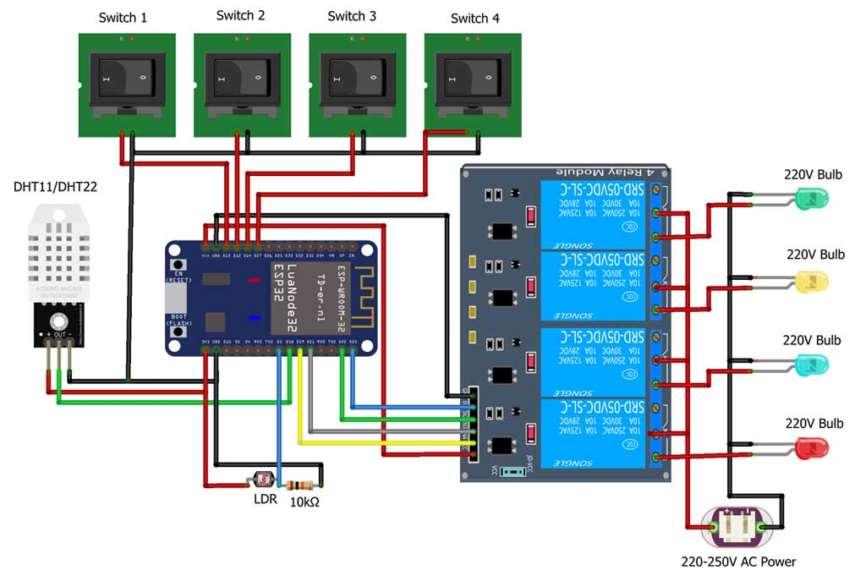

# PCB (selfmade): Handmade

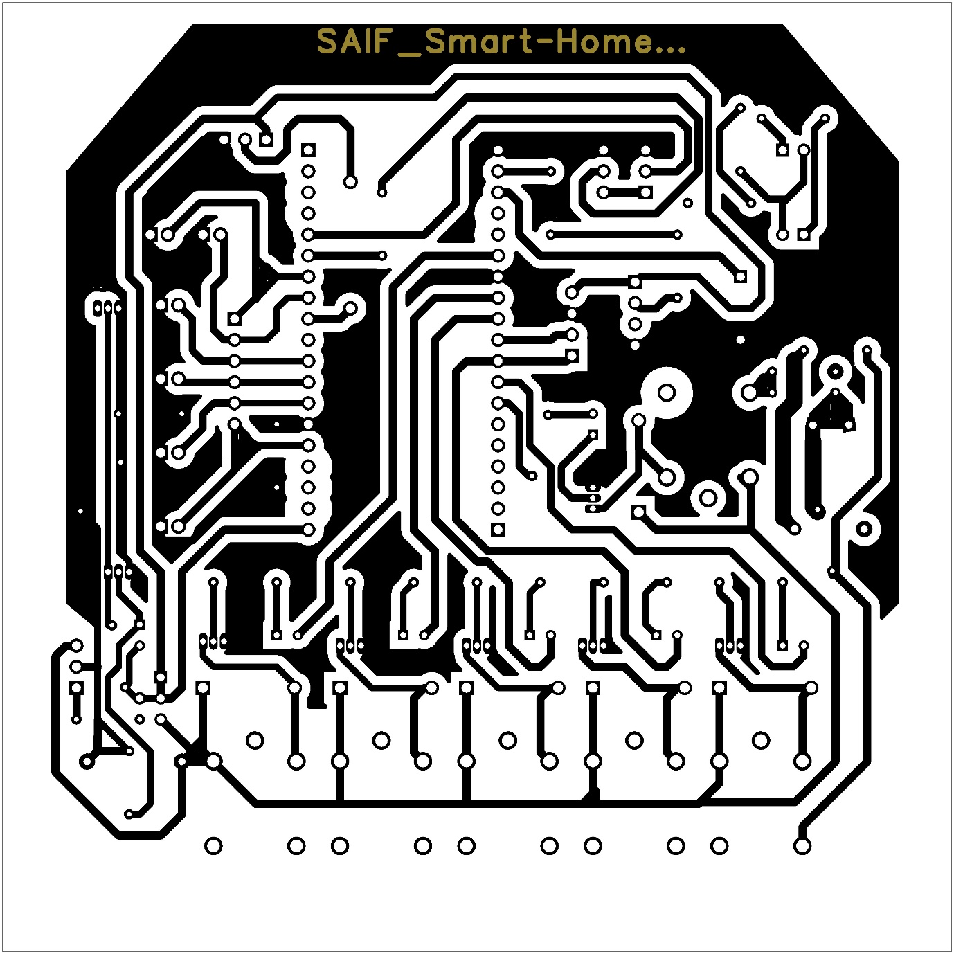

# Concept: Block Diagram

# Schematic Diagram :-